Jerome

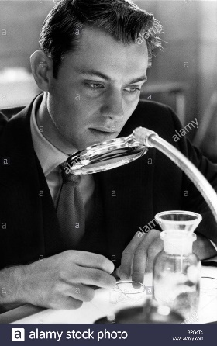

Jerome Eugene Morrow is the one character in the movie who is real and expresses his emotions in a dystopian society where people seem passionless. It is as if parents chose to remove the personality gene! But, if genetics guarantee your success then why be excited by achievement? Jerome is someone everyone can identify with, he makes mistakes, and he gets angry and excited and is sarcastic. We can connect with him.
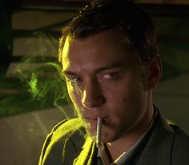
Andrew Niccol uses Jerome’s dynamic personality as a contrast to the Gattaca employees, who dress the same, walk the same and are passive in their reactions to events.

This is Jerome when we first see him. He wheels out smoking and looking angrily annoyed with the DNA shaped staircase behind him – mocking him as he can’t climb it. He passively sits there as he is observed by Vincent and German, the DNA broker, as they discuss him as if he is an item for sale. So what is Jerome’s motivation to be trapped in hiding, providing his name and DNA to Vincent? Vincent explains: “I paid the rent and kept him in the style to which he was accustomed.” He does have expensive tastes!
After Vincent goes through the painful process of having his legs stretched, he doesn’t question Vincent’s determination again and starts to open up. He show’s Vincent his
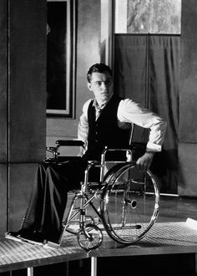

Olympic swimming medal, Vincent is not very interested, and just asks if it is real and says, well done, “Are you colour blind as well Vincent?” He points out that it is a silver medal, saying: “Jerome Morrow was never meant to be one step down on the podium.” He then asks Vincent in honest confusion, if he couldn’t do it with a perfect DNA quotient then how can Vincent do it?
Vincent refers to Jerome as “suffering under a different burden, the burden of perfection.” A burden that Jerome couldn’t cope with, as he confesses that he wasn’t injured in a car crash, but that he had tried to kill himself, “I couldn’t even get that right, could I? If at first you don’t succeed, try, try, again.” A warning to Vincent here!
Vincent, very generously! Offers to let Jerome out of the deal before he goes for his Gattaca interview. Can you imagine after all that pain and effort! “This is the last day that you’re going to be you and I’m going to be me. It’s not too late to back out.” Jerome turns him down and his reaction to Vincent getting into Gattaca was, “Of course you did.” Later in the novel he is shocked that he has to explain to Vincent, “When they look at you they don’t see you anymore, they only see me.” Vincent notes, “Jerome Morrow was engineered with everything to get into Gattaca, except the desire to do so.”
But, Jerome becomes more focused and driven once he starts working with Vincent. The bottles of alcohol disappear and they are replaced with books that are everywhere in the background shots of his apartment. He tells Vincent, that he got the better part of the deal, “I just lent you my body. You lent me your dream.”
Jerome also has a great sense of humour, “I could walk all the time, I’ve just been faking it.” Or when asked how tall he is: “Four foot six.” He gets angry, “You’re boring me!” and hangs up the phone. Or “What’s your number?!” he yells at the police officer. He is honest and open, when Vincent tells him that a Detective is coming to the house and he has to be himself for the day he replies, “I never was very good at it remember.” He is warm with Vincent, “I am proud of you Vincent.” But of course he has flaws, drinking too much and getting angry at the Cavendish Club and throwing up after. And generous, “There is enough for two life times.”

Other references to people being more products for sale than human: - German: “He has an expiry date you wouldn’t believe.” - Vincent: “I guess they don’t order South Paws anymore” - Dr. Lamar: “I don’t know why my parent’s didn’t order one like that.”
Here is the clip of this interaction
Here is the clip of this scene. (Explicit language)
There is a montage of Jerome Clips, but the resolution is low

